DELTAKERE

Country | First Name | Name | Date of birth | License since | Last year victories | This year victories | Total wins
Austria | Thomas | Royer | 13.11.1978 | 1997 | 23 | 4 | 180
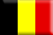Belgium | Sebastien | Grisez | 07.09.1990 | 2008 | 11 | 4 | 105
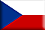Czech Republic | Alle Johannes Marinus | Loman | 08.09.1951 | 1996 | 24 | 0 | 148
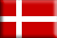Denmark | Svend Aage | Vindbjerg | 1952 | 1990 | 3 | 0 | 50
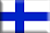Finland | Teemu | Keskitalo | 1991 | 2005 | 5 | 1 | 10
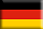Germany | Christoph | Pellander | 09.11.1978 | 2004 | 17 | 1 | 47
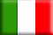 Italy | Giovanni | Bechis | 28.01.1951 | 1970 | 3 | 3 | 935
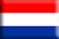 The Netherlands | Wim | Brouwer | 05.08.1964 | 1989 | 6 | 1 | 155
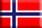Norway | Ernst Petter | Knutsen | 24.09.1958 | 1994 | 0 | 0 | 34
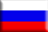Russia | Konstantin | Puchkov | 17.12.1951 | 1998 | 3 | 0 | 172
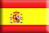Spain | Miquel | Vich Capó | 25.10.1984 | 1999 | 4 | 1 | 159
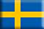Sweden | Håkan B. | Johansson | 29.03.1972 | 1993 | 13 | 4 | 231
Switzerland | Jean-Claude | Gardaz | 29.04.1966 | 1983 | 8 | 0 | 75

